**Tree Data Structure-**

Tree data structure may be defined as-

|  |
| --- |
| Tree is a non-linear data structure which organizes data in a hierarchical structure and this is a recursive definition.  **OR**  A tree is a connected graph without any circuits.  **OR**  If in a graph, there is one and only one path between every pair of vertices, then graph is called as a tree. |

**Example-**

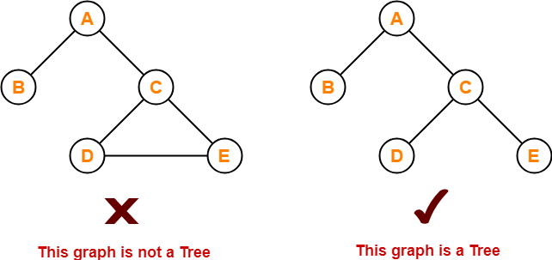

**Properties-**

The important properties of tree data structure are-

* There is one and only one path between every pair of vertices in a tree.
* A tree with n vertices has exactly (n-1) edges.
* A graph is a tree if and only if it is minimally connected.
* Any connected graph with n vertices and (n-1) edges is a tree.

To gain better understanding about Tree Data Structure,

[**Watch this Video Lecture**](https://www.youtube.com/watch?v=TRVSYBzVueY)

**Tree Terminology-**

The important terms related to tree data structure are-

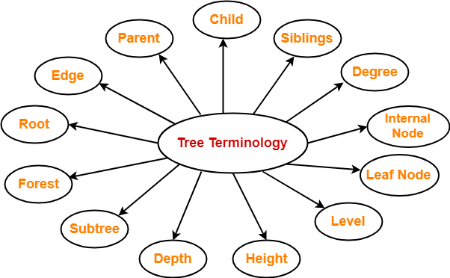

**1. Root-**

* The first node from where the tree originates is called as a **root node**.
* In any tree, there must be only one root node.
* We can never have multiple root nodes in a tree data structure.

**Example-**

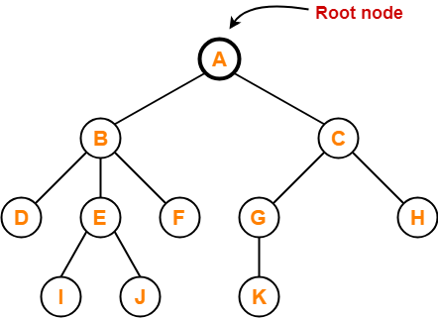

Here, node A is the only root node.

**2. Edge-**

* The connecting link between any two nodes is called as an **edge**.
* In a tree with n number of nodes, there are exactly (n-1) number of edges.

**Example-**

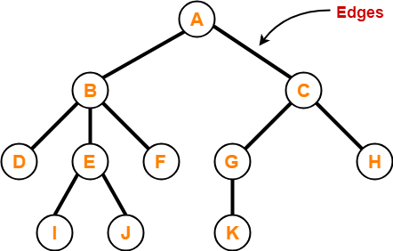

**3. Parent-**

* The node which has a branch from it to any other node is called as a **parent node**.
* In other words, the node which has one or more children is called as a parent node.
* In a tree, a parent node can have any number of child nodes.

**Example-**

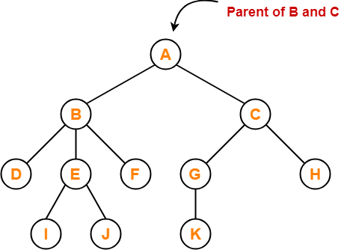

Here,

* Node A is the parent of nodes B and C
* Node B is the parent of nodes D, E and F
* Node C is the parent of nodes G and H
* Node E is the parent of nodes I and J
* Node G is the parent of node K

**4. Child-**

* The node which is a descendant of some node is called as a **child node**.
* All the nodes except root node are child nodes.

**Example-**

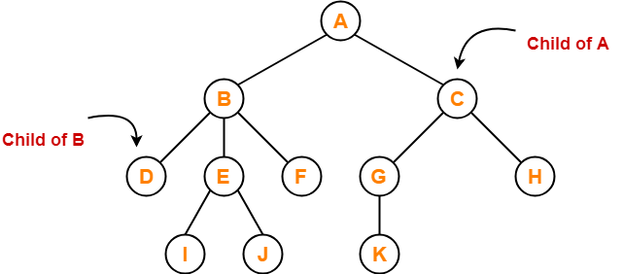

Here,

* Nodes B and C are the children of node A
* Nodes D, E and F are the children of node B
* Nodes G and H are the children of node C
* Nodes I and J are the children of node E
* Node K is the child of node G

**5. Siblings-**

* Nodes which belong to the same parent are called as **siblings**.
* In other words, nodes with the same parent are sibling nodes.

**Example-**

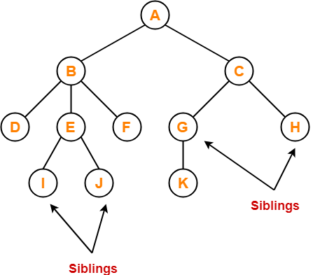

Here,

* Nodes B and C are siblings
* Nodes D, E and F are siblings
* Nodes G and H are siblings
* Nodes I and J are siblings

**6. Degree-**

* **Degree of a node** is the total number of children of that node.
* **Degree of a tree** is the highest degree of a node among all the nodes in the tree.

**Example-**

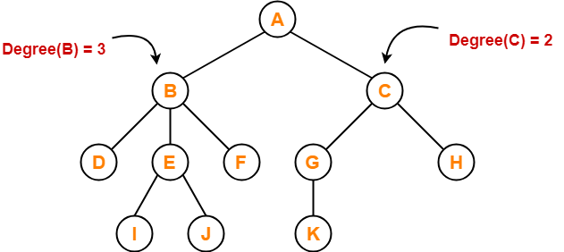

Here,

* Degree of node A = 2
* Degree of node B = 3
* Degree of node C = 2
* Degree of node D = 0
* Degree of node E = 2
* Degree of node F = 0
* Degree of node G = 1
* Degree of node H = 0
* Degree of node I = 0
* Degree of node J = 0
* Degree of node K = 0

**7. Internal Node-**

* The node which has at least one child is called as an **internal node**.
* Internal nodes are also called as **non-terminal nodes**.
* Every non-leaf node is an internal node.

**Example-**

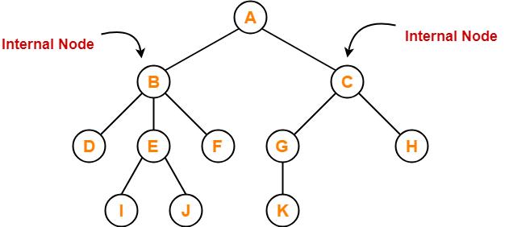

Here, nodes A, B, C, E and G are internal nodes.

**8. Leaf Node-**

* The node which does not have any child is called as a **leaf node**.
* Leaf nodes are also called as **external nodes** or **terminal nodes**.

**Example-**

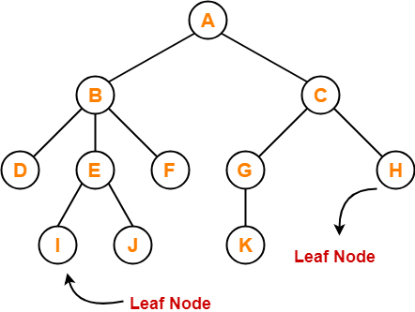

Here, nodes D, I, J, F, K and H are leaf nodes.

**9. Level-**

* In a tree, each step from top to bottom is called as **level of a tree**.
* The level count starts with 0 and increments by 1 at each level or step.

**Example-**

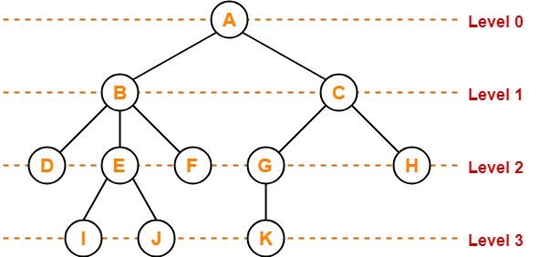

**10. Height-**

* Total number of edges that lies on the longest path from any leaf node to a particular node is called as **height of that node**.
* **Height of a tree** is the height of root node.
* Height of all leaf nodes = 0

**Example-**

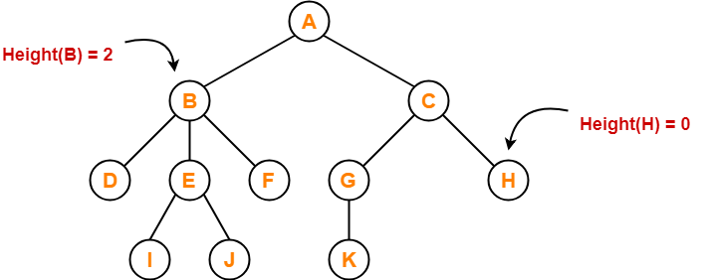

Here,

* Height of node A = 3
* Height of node B = 2
* Height of node C = 2
* Height of node D = 0
* Height of node E = 1
* Height of node F = 0
* Height of node G = 1
* Height of node H = 0
* Height of node I = 0
* Height of node J = 0
* Height of node K = 0

**11. Depth-**

* Total number of edges from root node to a particular node is called as **depth of that node**.
* **Depth of a tree** is the total number of edges from root node to a leaf node in the longest path.
* Depth of the root node = 0
* The terms “level” and “depth” are used interchangeably.

**Example-**

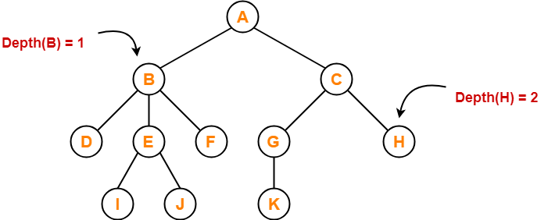

Here,

* Depth of node A = 0
* Depth of node B = 1
* Depth of node C = 1
* Depth of node D = 2
* Depth of node E = 2
* Depth of node F = 2
* Depth of node G = 2
* Depth of node H = 2
* Depth of node I = 3
* Depth of node J = 3
* Depth of node K = 3

**12. Subtree-**

* In a tree, each child from a node forms a **subtree** recursively.
* Every child node forms a subtree on its parent node.

**Example-**

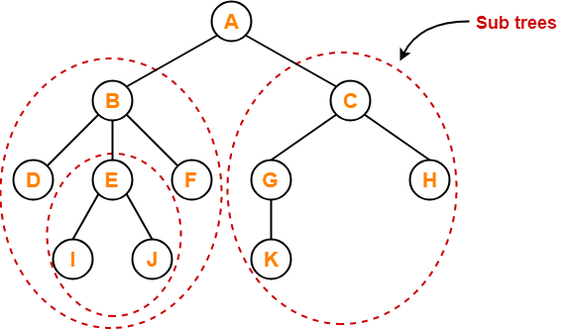

**13. Forest-**

A forest is a set of disjoint trees.

**Example-**

